RESUME 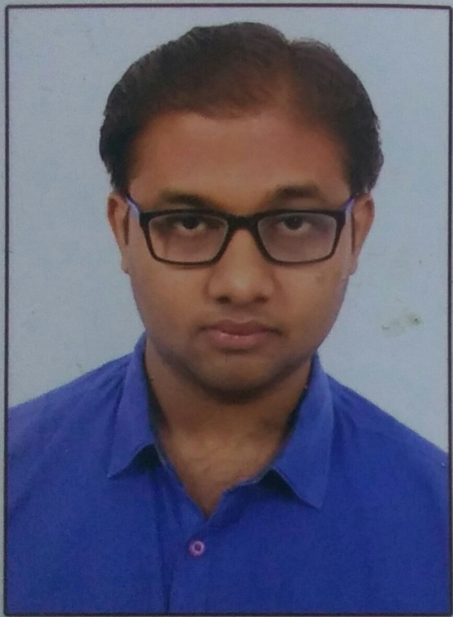

Name : JUTHANI NIRAV HARENDRABHAI

ADDRESS : “GAYATRI KRUPA”
11-Shantiniketan so. Street-5
B/H. Ranchod Nagar, Zanjarda road,
Junagadh..

DATE OF BIRTH : 18 / 10 / 1993

SEX : MALE

QUALIFICATION : (STANDARD) (BOARD/UNI.) (RESULT)

1. S.S.C G.S.E.B 51.08%

2. H.S.C G.S.E.B 60.5%

3. CGPI GTU 6.46
4. CPI GTU(2016) 5.47

QUALIFICATION : B.E CIVIL

STATE : GUJARAT

FATHER OCCU. : BUSINESS

HOBBY : CRICKET, LISTEN SONGS, READING

MARITIAL STATUS: UNMARRIED

EXPERIENCE : 1 YEAR

SKILL : AUTO CAD 2D

CONTACT NO. : 9426462514

E-mail : nhjuthani@gmail.com

